XI Brazilian Conference on Rheology
BCR
Vitória - 2026

Title should be in Times New Roman, size 16, centered and bold

1st Author’s Name1, 2nd Author2, 3rd Author3 (Times New Roman, size 12, centered, bold)
11First Author(s) affiliation(s) and address(s) (Times New Roman, size 12, centered)
* Corresponding author e-mail (Times New Roman, size 12, centered)

- INTRODUCTION

This template for the XI BRAZILIAN CONFERENCE ON RHEOLOGY (BCR 2026) serves as the guideline for paper preparation. The paper should not exceed four (4) pages. T XI_BCR_2026he standard font for the body text is Times New Roman, size 12, with justified text and single spacing. The page size is A4. The first paragraph is not indented, while the following paragraphs have an indent of 0.75 cm.
An acknowledgments section can be added at the end of the paper.
Save the document as a PDF named BCR_paper_name, replacing “name” with the presenting author's full name. Submit the paper to SBR via its website. Kindly note that papers exceeding four pages will be returned to the authors.

- SPECIFIC INSTRUCTIONS

Mathematical equations should not be indented and are referenced as “Equation (1)” at the beginning of a sentence or “Eq. (1)” within a sentence. Mathematical symbols must be written in italic, and each symbol should be defined either immediately before or after its first appearance. Blank lines should be included before and after every equation. Equation (1) presents a regularized formulation for the viscosity of the Bingham model, $η$:

$η=\frac{τ_{y}}{\left|\left|\dot{γ}\right|\right|+ϵ}+μ_{P}$ | (1)

Here, where $τ_{y}$ is the yield stress, $\left|\left|\dot{γ}\right|\right|$ is the magnitude of the strain rate tensor, $ϵ$is the regularization parameter, and $μ_{P}$ is the plastic viscosity.

  - Figures and tables

Figures and tables are allowed and must be properly referenced in the text. When they appear at the beginning of a sentence, use the long form such as “Figure 1” or “Table 1”. When referenced within a sentence, use the short form “Fig. 1” or “Tab. 1”. Captions for figures should be placed below the figure, whereas captions for tables should appear above the table.

    - Figures

Blank lines should be included immediately before and after each figure or table. The letters and numbers within figures must be similar in size to the main text to ensure readability, as illustrated in Fig. 1.

    - Tables

The table format is free, but must be centered with the caption at the top as the example in Tab. 1. Use of bold titles inside the table is preferable for better readability.

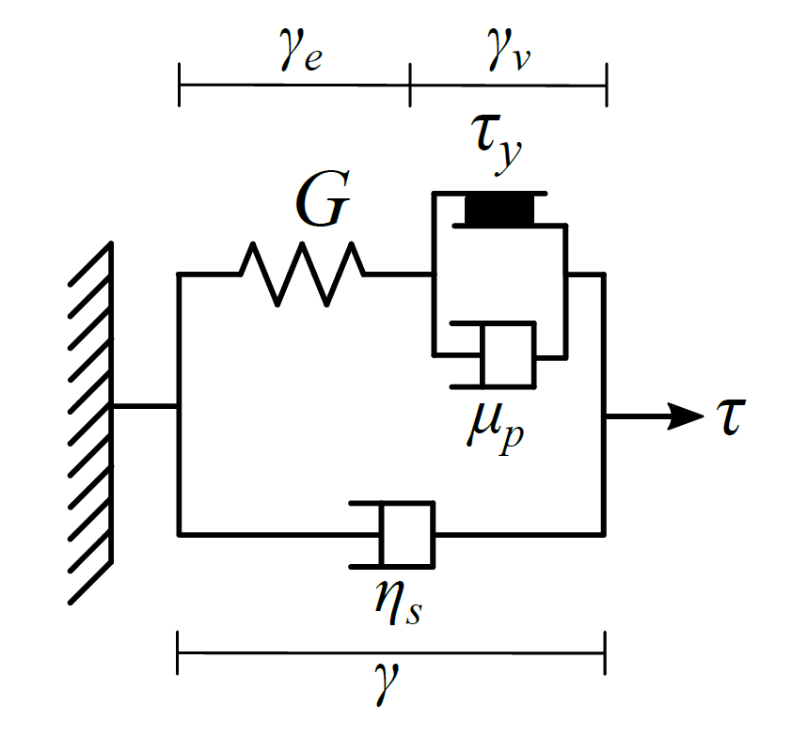
Figure 1: Mechanical analog of an elasto-viscoplastic model.

Table 1 presents the dimensionless numbers employed in the parametric numerical analysis.

Table 1: Dimensionless number employed in the analysis.

Dimensionless number |  | Values
Reynolds number (Re) |  | 1; 10; 100
Weber number (We) |  | 1; 10; 100
plastic number (Pl) |  | 0.0; 0.2; 0.8

- CONCLUSIONS

We are looking forward to meeting you in Vitória-ES.

- ACKNOWLEDGMENTS

This section is optional.

REFERENCES

References should be listed at the end of the document, following the order of citation in the paper. Use Times New Roman, size 10, for the font, and align the references to the left. Each reference should be designated by a number in brackets [1]. When citing two references simultaneously, include them together as [2,3], separated by a comma. For three or more consecutive references, denote them with bounding numbers and a dash [2-4].
[1] V. C. Kelessidis, R. Maglione, C. Tsamantaki, and Y. Aspirtakis. Optimal determination of rheological parameters for Herschel–Bulkley drilling fluids and impact on pressure drop, velocity profiles and penetration rates during drilling. Journal of Petroleum Science and Engineering, 53(3–4):203–224, 2006.
[2] R. de Paula Cosmo, F. A. R. Pereira, E. J. Soares, and A. L. Martins. Modeling and validation of the CO2 degassing effect on CaCO3 precipitation using oilfield data. Fuel, 310:122067, 2022.
[3] L. H. P. Deoclecio, E. J. Soares, and S. Popinet. Drop rise and interfacial coalescence initiation in Bingham materials. Journal of Non-Newtonian Fluid Mechanics, 319:105075, 2023.
[4] J. Pierson, J. Magnaudet, E. J. Soares, and S. Popinet. Revisiting the Taylor-Culick approximation: Retraction of an axisymmetric filament. Physical Review Fluids, 5(7):073602, 2020.

